Experiment No.: 2 SISO, SIPO, PISO, & PIPO
AIM: To write VHDL code, simulate with test bench, synthesis, implement on PLD for Universal shift register with mode selection input for SISO, SIPO, PISO, & PIPO.

PREREQUISITE:

- Concept of Shift Register
- Types of Shift Register

OBJECTIVES:
- Write VHDL code for SISO, SIPO, PISO, & PIPO.
- Synthesize, simulate the design writing test bench using Modelsim Simulator.

EQUIPMENTS & COMPONENTS:
- Xilinx 14.7 ISE EDA tool for coding and synthesis.
- Modelsim simulator for simulation.
- Spartan6 board for implementation.

THEORY:

Serial in to Serial out (SISO) Shift Register:
SISO Shift register is very similar to the SIPO except were before the data was read directly in a parallel form from the outputs QA to QD, this time the data is allowed to flow straight through the register and out of the other end. Since there is only one output, the DATA leaves the shift register one bit at a time in a serial pattern, hence the name Serial-in to Serial-Out Shift Register or SISO. The SISO shift register is one of the simplest of the four configurations as it has only three connections, the serial input (SI) which determines what enters the left hand flip-flop, the serial output (SO) which is taken from the output of the right hand flip-flop and the sequencing clock signal (Clk). The logic circuit diagram below shows a generalized serial-in serial-out shift register.

Serial in to parallel out (SIPO) Shift Register:
A serial-in/parallel-out shift register is similar to the serial-in/ serial-out shift register in that it shifts data into internal storage elements and shifts data out at the serial-out, data-out, pin. It is different in that it makes all the internal stages available as outputs. Therefore, a serial-in/parallel-out shift register converts data from serial format to parallel format. If four data bits are shifted in by four clock pulses via a single wire at data-in, below, the data becomes available simultaneously
on the four Outputs QA to QD after the fourth clock pulse.

The Shift Register is a type of sequential logic circuit that can be used for the storage and transfer of data in the form of binary numbers. This sequential device loads the data present on its inputs and then moves or shifts it to its output once every clock cycle.
The 4-bit Universal Shift Register consists of 4 single bit D Flip-Flops connected together in a serial type daisy-chain arrangement so that the output from one data latch becomes the input of the next latch and so on.
MODE SELECT | OPERATION
00 | SISO Right Shift
01 | SIPO
10 | PIPO
11 | SISO Left Shift

The table of the 2-bit mode selects and the corresponding operation performed at the mode select value is:
Basic Data Movement Through A Shift Register
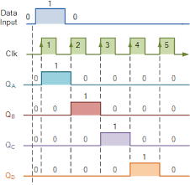
Clk  pulse No | QA | QB | QC | QD
0 | 0 | 0 | 0 | 0
1 | 1 | 0 | 0 | 0
2 | 0 | 1 | 0 | 0
3 | 0 | 0 | 1 | 0
4 | 0 | 0 | 0 | 1

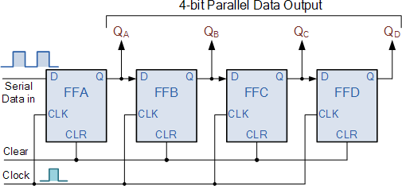

All in all, there are 4 modes of operations, which are:
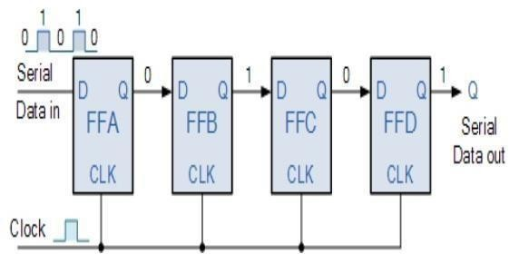

Serial In Serial Out (SISO) Mode:
There is only one output, data leaves the shift register one bit at a time in a serial pattern, hence the name Serial In Serial
Out Register or SISO. It is one of the simplest of all the four configurations as it has only three connections, serial input(SI) which determines what enters the left hand flip-flop, the serial output (SO) which is taken from the output of right hand flip-flop and the sequencing clock signal (clk).
We have a mode control option wherein we can select if we want a right shift or left shift operation. The logic circuit diagram on the next page shows a generalized SISO shift register.

You may think what‟s the point of a SISO shift register if the output data is same as that of input data. Well this type of shift register also acts as a temporary storage device or it can act as a time delay device for the data.

Serial In Parallel Out (SIPO)Mode:
In this mode, there is one input where data comes in serially and being a 4 -it data, there are 4 output ports, one each from each D flip flop. Hence it is identified as Serial In Parallel Out. The circuit below shows the 4 bit SIPO mode.

Parallel In Serial Out (PISO) Mode:
This mode is characterized by a parallel port input for each of the 4 flip flops and one final output port at the end of the last flip flop. It is shown in the diagram below. PISO can operate in two modes namely Load or Shift mode. But for our sake, due to coding limitations, PISO operation will not be performed. However, for knowledge sakes, PISO is done using IC74194 Bidirectional Universal Shift Register.
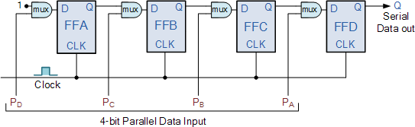

Parallel Input Parallel Output(PIPO) Mode:
This mode is also one of the simplest modes of operation. It has 4 bit parallel input as well as output for each flip flop and takes the least clock cycles. As soon as a clock edge is applied, the input binary bits will be loaded into the flip flop simultaneously. The loaded bits will appear
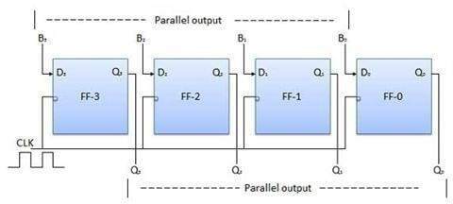

simultaneously to the output side. Only clock pulse is essential to load all the bits. The circuit is shown below:

PROCEDURE:
- Create a new Project, select new source as VHDL module and write the VHDL code for the intended design
- Perform Check syntax operation to verify that the code is syntactically correct.
- View RTL schematic and observe the Block diagram and its detailed connection.
- Study the synthesis report in detail.
- Launch Modelsim Simulator, force signals to the inputs in signal window, run the simulator and observe the output in Wave window.
- Write VHDL testbench for the Design-under-test (DUT) and simulate it to observe the behavior of design.
- Select the target FPGA device.
- For the VHDL file, create Implementation constraint file.
- In UCF file, assign package pins to the input and output ports of design object list as per the selected target device.(The pin numbers can be referred from the Matrix II board manual.
- Implement the design which includes translation, mapping, placement and routing.
- Select the FPGA startup clock and configuration mode as per the selected target FPGA device (Spartan 2 or 3).
- Add Xilinx device, select the appropriate bit file and program the FPGA.
- Apply the input through onboard switches or interfaced Add-on Module and observe the output on the intended output device which may be LED/LCD/SSD/Add-on Module

SISO PROGRAM:

library IEEE;
use IEEE.STD_LOGIC_1164.ALL;
use IEEE.STD_LOGIC_arith.ALL;
use IEEE.STD_LOGIC_unsigned.ALL;
entity shift_register is
Port ( CLR : in STD_LOGIC; -- clear input
SEL : in STD_LOGIC_VECTOR (1 downto 0);
SHF_LOAD : in STD_LOGIC;
Serial_In : in STD_LOGIC; -- serial input
clk_50mhz : in STD_LOGIC;
CLK_LED : out std_logic; -- to indicate divided clock freq
D : in STD_LOGIC_VECTOR (3 downto 0); -- Parallel D i/ps
Q : inout STD_LOGIC_VECTOR (3 downto 0));
end shift_register;

architecture Behavioral of shift_register is
signal divider : std_logic_vector(1 downto 0):= (others => '0');
signal clk : std_logic;
begin

process(clk_50mhz,clr)
begin
if clr='0' then
divider <= (others=>'0');
elsif clk_50mhz'event and clk_50mhz='1' then
divider <= divider + "01";
end if;
end process;

CLK <= divider(1);
CLK_LED <= divider(1);

process(CLK,clr)
begin
if (CLR='0')then
Q<="0000";
elsif(clk'event and clk='1') then
if (SHF_LOAD='0')then -- Parallel Load
Q <= D;
else

if(SEL="00")then ----Shift Right Operation
-- alternate code
-- Q <= Serial_In & Q(3 downto 1);
Q(3)<=Serial_In;
Q(2)<=Q(3);
Q(1)<=Q(2);
Q(0)<=Q(1);
end if;
if(SEL="01")then ----Shift left Operation
-- alternate code
-- Q <= Q(2 downto 0) & Serial_In ;
Q(0)<=Serial_In;
Q(1)<=Q(0);
Q(2)<=Q(1);
Q(3)<=Q(2);
end if;
if(SEL="10") then ----Rotate left
Q <= D(2 downto 0) & D(3);
end if;
if(SEL="11") then ----Rotate Right
Q <= D(0) & D(3 downto 1);
end if;
end if;
end if;
end process;

end Behavioral;

Conclusion

Viva questions on exp -2
1.Name the four main types of shift reg.
2. What is propagation delay?
3. Which flip-flop is preferred?
4. Why is clock synchronization crucial?
5. What is a bidirectional register
6. What is a practical application of shift register?

